North-Eastern Hill University, Tura Campus, Tura, Meghalaya
[Bioinformatics Center, Department of RDAP,P.O.-Lower Chandmari-794002,District-West Garo Hills, Tura, Meghalaya]
[Centre’s Email: drbkm1972@yahoo.co.in]
[Contact number: 09436306259]
1. Background: The Bio-Informatics Facility (BIF) of NEHU, Tura campus was sanctioned in the month of Feb, 2008 and we received the sanctioned order in the month of March 2008. The center has constituted a management committee as defined in the ToR and the committee is headed by the Pro-Vice chancellor, North-Eastern Hill University, Tura campus, who also happens to be the institutional Head of NEHU, Tura campus. This center is attached with the Department of Rural Development and Agricultural Production. The department has a full-fledged demonstration farm and well equipped laboratory for rural development, horticulture production, livestock production, Dairy Technology agriculture and other allied activities. The site itself is a treasure of flora and fauna. As a beginning step of building database, the demonstration itself would be the initial point. This has already been started by the research scholars and the students as part of their curriculum.
2. Status of the Centre: BIF
3. Area of specialization: Animal Husbandry& Dairying (Dairy Technology), Horticulture, Rural Development, Systems Biology, Network Biology, Computational Biology
4. Infrastructure facilities available in the Centre:
S.N | Hard/Software/ Equipment’s | Quantity (Nos)
1. | Computer H.P. Compaq | 10
2. | Work Station | 02
3. | UPS | 12
4. | Computer table and chair | 12 each
5. | IBM Server Medium end | 01
6. | Microsoft visual studio Professional 2012 | 01
7. | Microsoft SQL Server Cal (5 CAL) | 01
8. | Microsoft Windows R Sever 2012 Standard | 01
09 | Microsoft Windows Sever 2012 User CAL (5 CAL) | 02
10 | UPS 1100 VA APC | 01
11 | UPS 1000 VAT | 01
12 | H P Desk Jet Printer | 01
13 | UPS 600 VAT | 08
14 | Hard Disk Internal 500GB | 01
15 | H P Laser jet with networking Printer | 01
16 | LCD Projector SHARP PG LX-2000 | 01
17 | Xerox Machine + Voltage Stabilizer Canon iR 2002 | 01
18 | Digital Podium Strake SRP-60M | 01
19 | Online UPS (Numeric) 3 KVA | 01
20 | Desktop PC HP AIO Core-i3 | 01
21 | Note Book + Tab (Acer one 10) | 02
22 | LCD projector presenter (iBall) | 03

5. Details about Staff members working in the centre:
SN | Name | Designation | Specialization | Absorption Status
1 | Dr B K Mishra | Assistant Professor cum Coordinator | Dairying Science & Technology | Permanent
2 | Dr B Mathew | Assistant Professor cum Co-Coordinator | Horticulture | Permanent
3 | Dr K B Achary | Research Associate | Systems Biology | Contractual/ Temporary
4 | Annapurna Saikia | Traineeship | Computer Science | Contractual/ Temporary
5 | Dyna Lal | Traineeship | Bioinformatics | Contractual/ Temporary
6 | Biswajit Bora | Studentship | Bioinformatics | Contractual/ Temporary

6. Training/Workshop organized in last on year-
SN | Title | Date | Level of Participants | No of Participants
1 | Three Days Short Term Training Course on Bioinformatics: Biology on Your Computer | 6th-8th October,2015 | Teachers, Researchers, PhD and PG students | 20
2 | One Day National Seminar on  Advances of Bioinformatics and Computational Biology in Applied Biotechnology. (In Collaboration with BIF Centre) | 5th October, 201 | Teachers, Researchers, PhD and PG students | 135

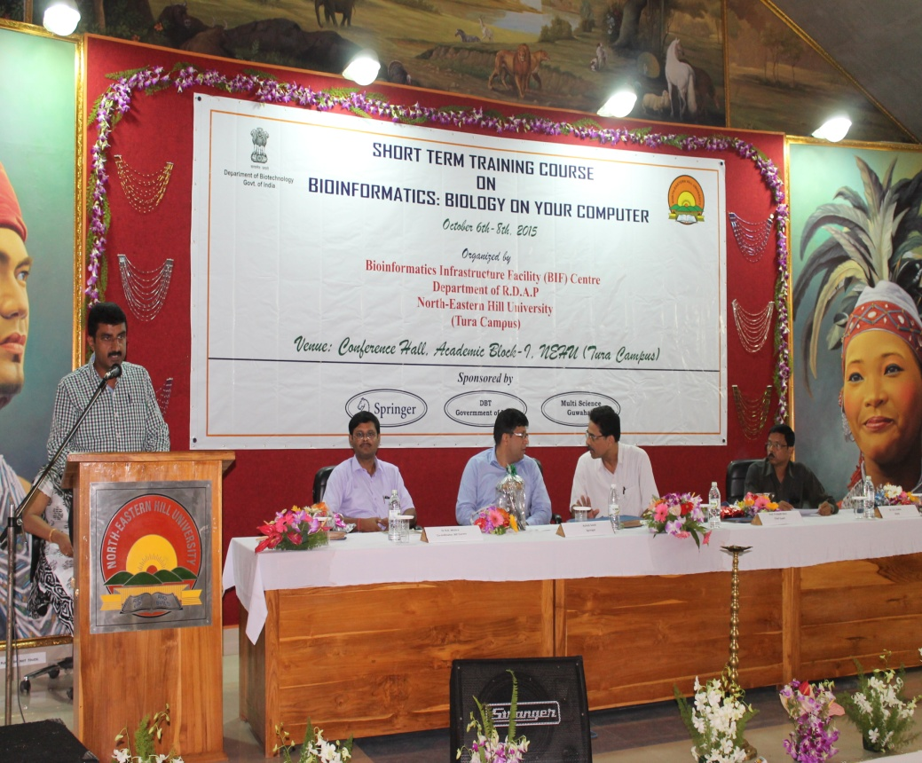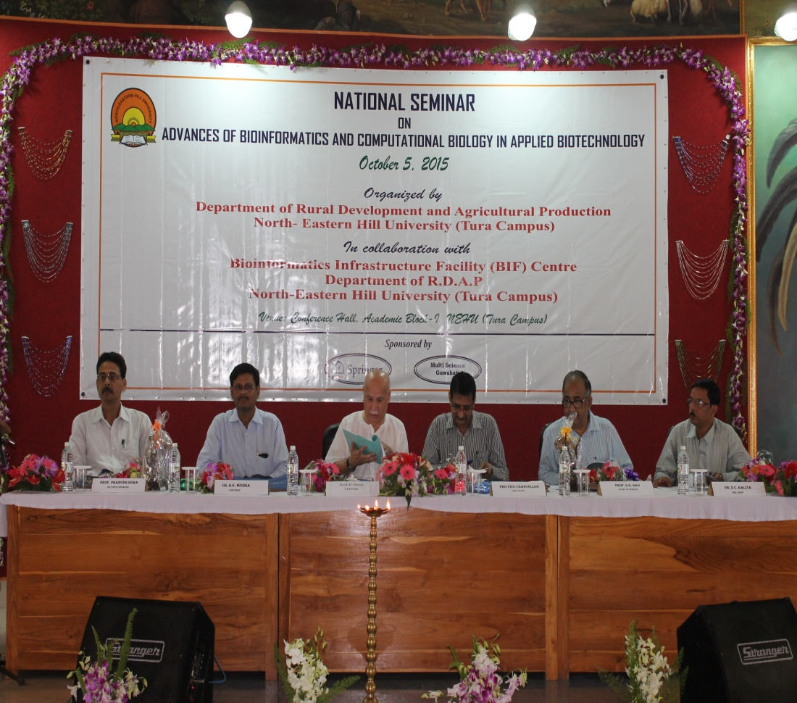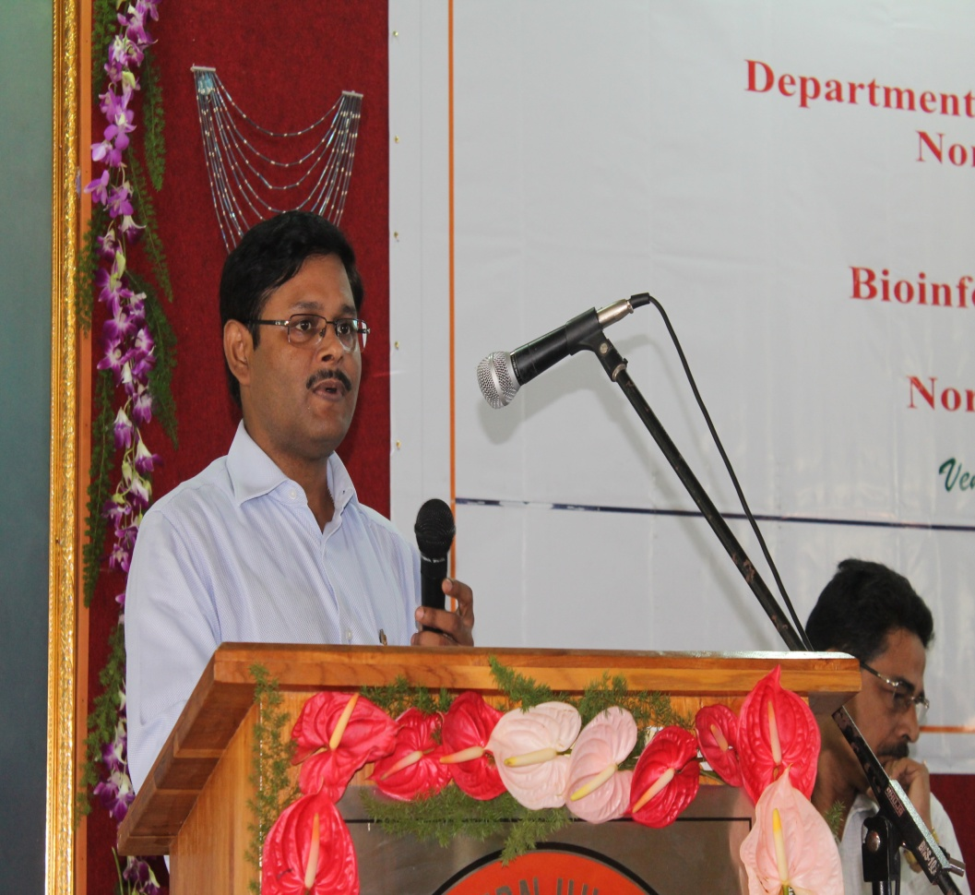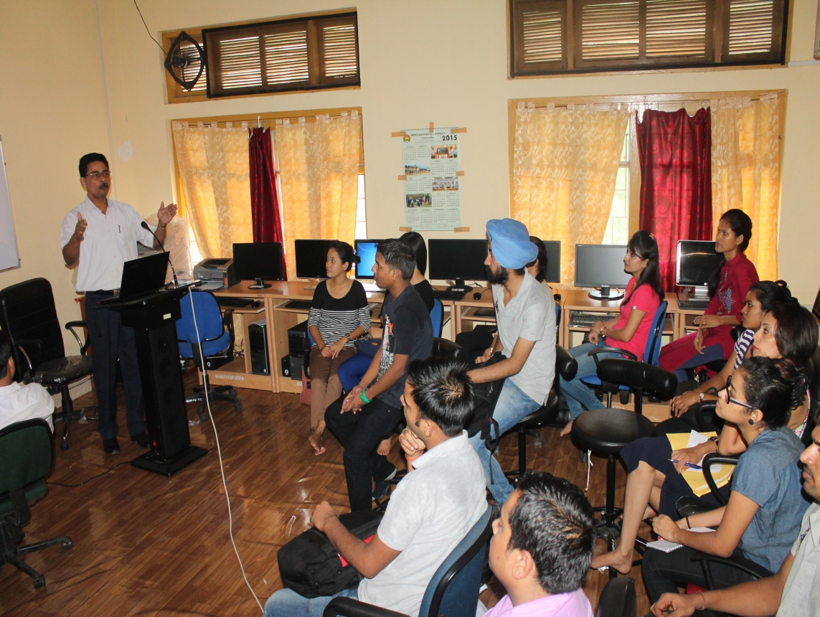

7. Research activities in Bioinformatics:
- Mr Biswajit Bora, from Dibrugarh University has completed his dissertation work for the completion of M.Sc Bioinformatics under the studentship from this centre. His title of research was “pBio: An open source java library for the Analysis of Protein Stability and Disorder”
- Insilco approach has been incorporated to design siRNA for sweet potato leaf curl disease
- Gene interaction networks has been developed for type 2 diabetes genes
- Prospects of multi cloud collaboration in Bioinformatics have been initiated.
- Downy Mildew research prospects with respect to Indian scenario.
- Web page designing work of the centre has been initiated.
- Research work started on Physico-Chemical and Microbial quality of fermented beverages of Garo Hills, Meghalaya.
- one Major Project titled “Bio-prospecting of Lactic Cultures from North-Eastern Regions to Develop Functional Fermented Soya Foods with potential health benefits” funded by DBT (Twinning) in collaboration with ANAND Agriculture University Gujrat is going on.

8. Papers presented in the conferences:
- Bora B , Achary K B, Mishra B K (2015) “pBio: An Open Source Java Library for The Analysis of Protein Stability and Disorder” national seminar on “Advances of Bioinformatics and Computational Biology in Applied Biotechnology” at NEHU, Tura Campus,5th Oct, 2015
- Achary K B, Bisht S S , Mishra B K “Gene Interaction Networks of Type 2 Diabetes Genes Improves Disease Intervention” national seminar on “Advances of Bioinformatics and Computational Biology in Applied Biotechnology “ at NEHU, Tura Campus,5th Oct,2015
- Lal D, Baalaji N S (2015) “An Insilico Approach to Design Potential siRNA for Viral (Begomoviruses) Disease in Sweet Potato Plant” national seminar on “Advances of Bioinformatics and Computational Biology in Applied Biotechnology “ at NEHU, Tura Campus,5th Oct,2015
9. Proposed activities for the next year

The North Eastern Hill University, Tura Campus has been already shifted to its new and permanent site. In the permanent campus the Department of RDAP has been earmarked and the Bioinformatics lab is established in the Department. At permanent site the following activities have been envisaged to be taken up:
- We are planning to conduct a three day training program on “Network Biology: An Insight Towards System Level Understanding of Biology and Disease Pathologies” from Dec 15-17,2015
- We are planning to conduct a two day training program on “Sequence Alignment and Variations” from March 20-21,2016
- Research work on computational analysis of downy mildew resistance gene RRP in Arabidopsis Thaliana.
- Research work on insilico sequence analysis of BSP1,ACAN and MSTN of Bos taurus.
- Research work will start on mutual co-evolutionary relationship between residues in a protein family, GSEA approach on available microarray data, Gene regulatory network etc.
- Working on Sclerocis: Current Indian Scenario.
- Training program to encourage the research scholars of the department and other institutions to make use of bioinformatics facilities in their respective research works.
- To continue spreading awareness, knowledge sensitization by imparting hands-on training in the areas of bioinformatics and biotechnology to the students from various school/college of nearby areas.
- Fostering partnership, collaborative research, industry institute partnership and entrepreneurship development to achieve the status of center for excellence in advanced training in Bioinformatics and Biotechnology.
Proposed Budget for the Next Financial Year
A. Recurring
Seminar/Training Program | Rs. 1,00,000/-
Contingency | Rs. 3,00,000/-
Travel Grant | Rs. 1,00,000/-
Manpower Salary (RA) | Rs. 4,75,200/-
Studentship | Rs. 96,000/-
Traineeship | Rs. 96,000/-
B. Non-Recurring
Equipment/Software | Rs. 5,00,000/-

Contact details:
Name of the Coordinator | Dr. B. K. Mishra
Name of Co-Coordinator | Dr. B. Mathew
Postal Address | Department of RDAP, NEHU, Tura Campus, Tura, P.O. Lower Chandmari-794002
Phone Number/ Mobile. No. | 03651-223107/ 09436306259
Fax No. | 03651-223953
Email | drbkm1972@yahoo.co.in  birendramishra14@gmail.com
Website | www.nehu.ac.in/tura

